Are you or someone you know a middle school or high school student who has an interest and passion for filmmaking?
Join us during the fall semester at WQED Film Academy to learn all the skills needed and make original projects to call your own!

FOR HIGH SCHOOL TEENS

WQED Film Academy
WQED Film Academy—in-person or vir- tually—is open to 9th graders through 12th graders to learn skills to become a digital storyteller with opportunities to become a PAID member of our Teen Film Crew.

In Person in our WQED Studios:
September 27 – December 22, 2022

4:00 – 8:00 PM
Tuesday and Thursday

Virtual on Zoom:
September 26 – December 21, 2022

4:30 – 6:00 PM
FOR MIDDLE SCHOOL TEENS

WQED Film Academy Lite
WQED Film Academy Lite is a three week film education program where students will learn filmmaking from start to finish- from pre-production to videography to post-production and editing. Film Academy Lite will be of- fered Wednesdays, 6:00 – 8:00 PM for three weeks.
There are two sessions this fall:

October 5th-October 19th
OR

November 2nd-November 16th

Monday, Wednesday, and Friday EDUCATORS! ASK ABOUT

TO LEARN MORE VISIT:
filmmakers.wqed.org
WQED FILM ACADEMY
ON LOCATION!

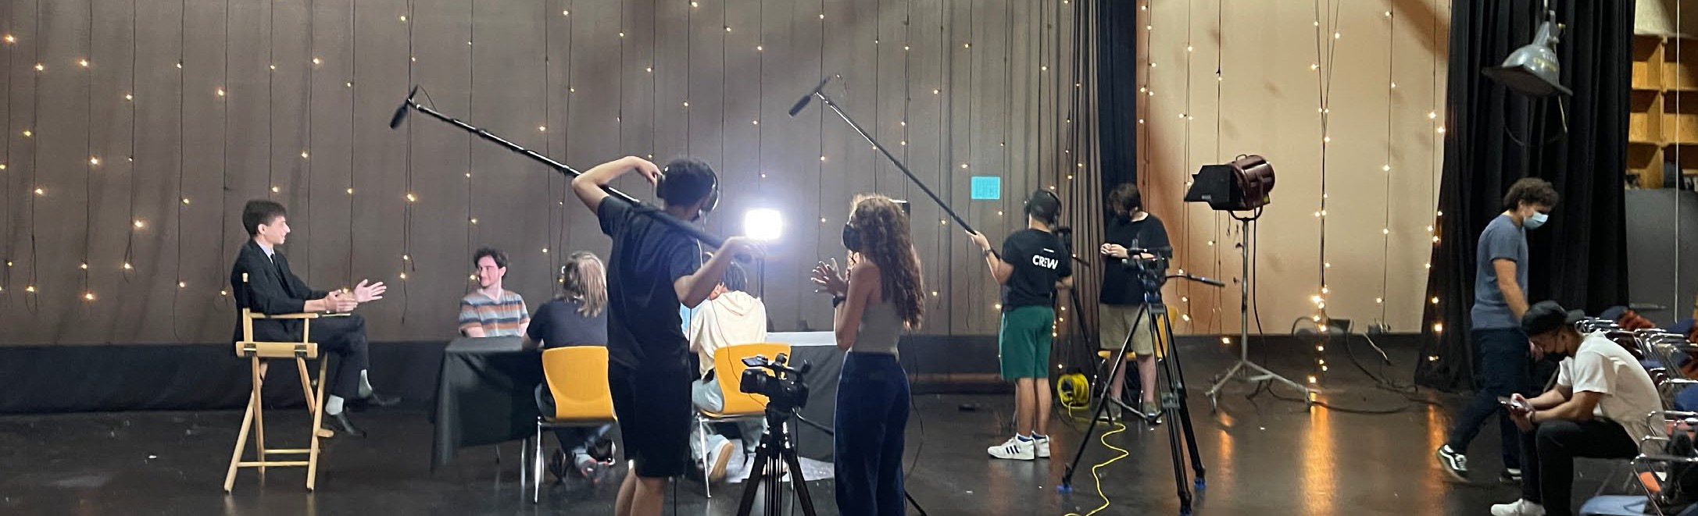
WANT TO MAKE A MOVIE WITH US?

Questions? Contact Program Manager, Ian Altenbaugh ianaltenbaugh@wqed.org Dates, times, and format are subject to change.

